**EE307 Digital Electronics and Integrated Circuits**

**Class Midterm 1**, **February 10/11, 2016**

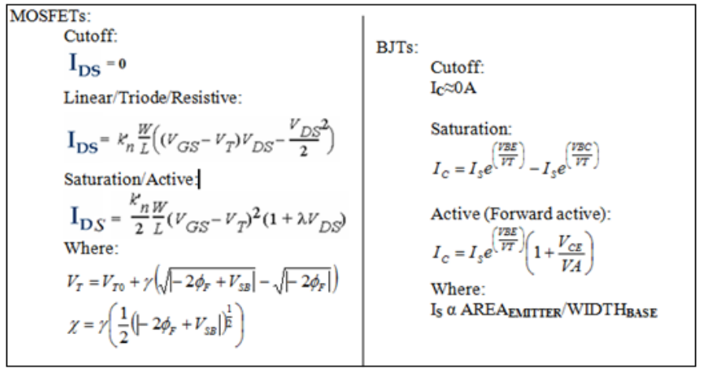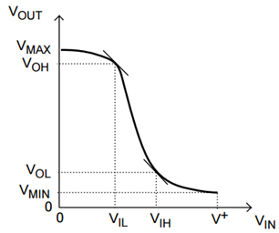

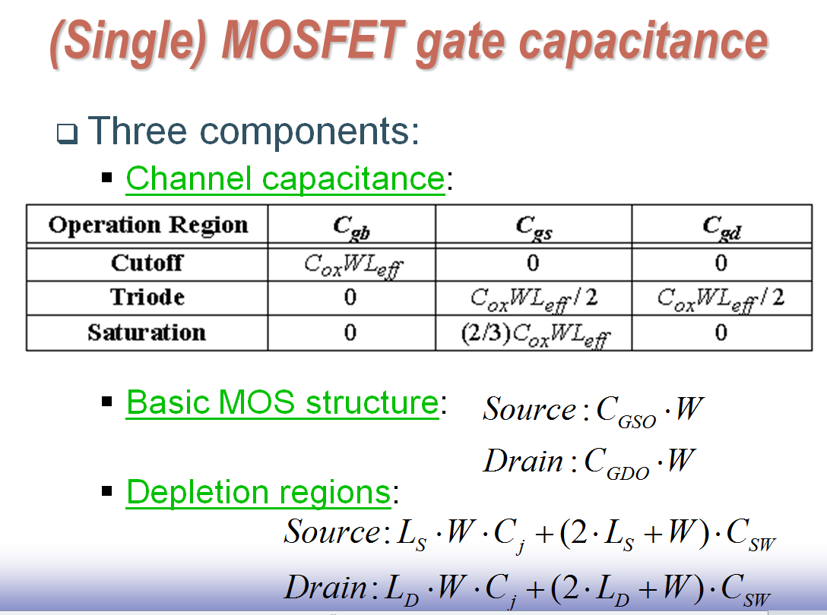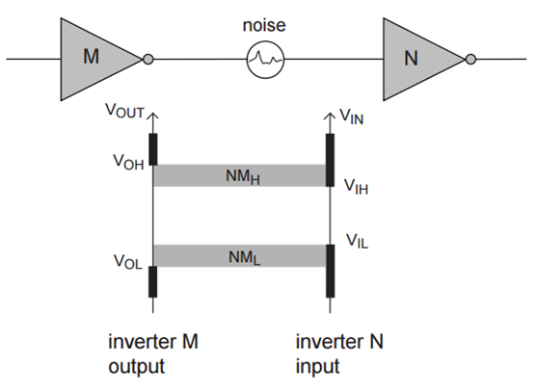

No calculators.

Only the attached cheat sheet allowed.

No cheating.

Show work where asked (or no credit!).

Rules:

**NAME:** ____________________________________________

I promise not to discuss this exam with those that have not taken it yet.

Signature:________________________________________



|  |  |  |
| --- | --- | --- |
| Question | Pts | Score |
| 1 | 4 |  |
| 2a-k | 37 |  |
| 3 | 6 |  |
| 4 | 5 |  |
| Total | 52 |  |

**EXAM:**

1. (4pts) Draw the complementary MOSFET implementation of 

Show manipulation of logic equation to find pulldown logic.

**ANSWER:**



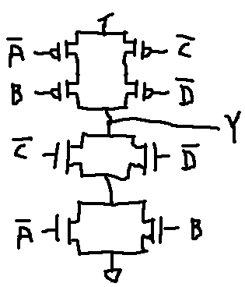

1. Delays (Total: 37pts)

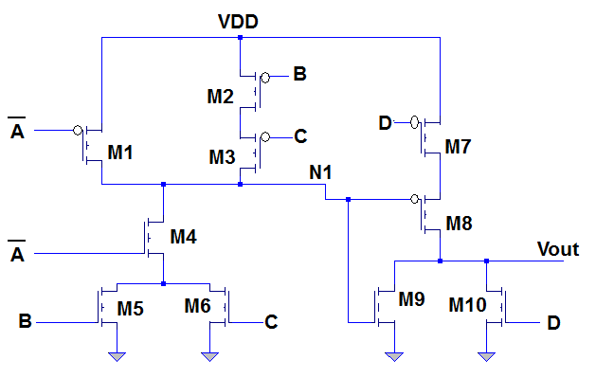

Circuit 1

* 1. Circuit 1 is two cascaded CMOS circuits. What is the logic of the first stage? No need to do any simplification. (3pts)

**ANSWER:** 

* 1. What is the value at N1 when: A=B=C=D=0? (2pts)

**ANSWER:** N1 🡪 VDD

* 1. What is the value at Vout for the same inputs: A=B=C=D=0? (2pts)

**ANSWER:** Vout 🡪 GND

* 1. What is the value at N1 when: A=C=D=0 and B=1? (2pts)

**ANSWER:** N1 🡪 GND

* 1. What is the value at Vout for the same inputs: A=C=D=0 and B=1? (2pts)

**ANSWER:** Vout 🡪 VDD

* 1. What is the perceived capacitance (capacitance with Miller effect included) at N1? Use subscripts to show which transistor each capacitance belongs to. (6pts)

**ANSWER:**



* 1. Use the two point approximation on the graph at the end of the exam to find Ron for a PMOS. No need to simplify. Just set up the equation. Assume VDD=3V. (4pts)

**ANSWER:**



* 1. Use the one point approximation on the graph at the end of the exam to find Ron for a NMOS. No need to simplify. Just set up the equation. Assume VDD=3V. (4pts)

**ANSWER:**



* 1. What is the time constant for the transition caused by changing the inputs from A=B=C=D=0 to A=C=D=0 and B=1? (6pts)

**ANSWER:**

The first inputs give the following RC network and tells you that all capacitances get charged to VDD:

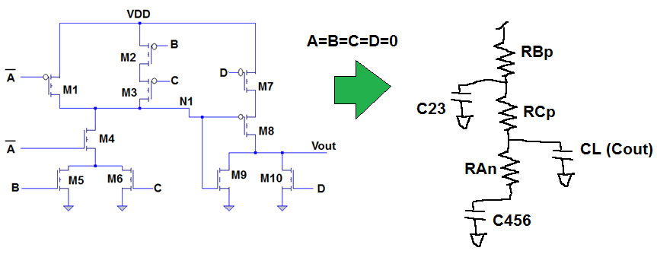

The next inputs generate the following RC network and show that all capacitances discharge to GND**.**

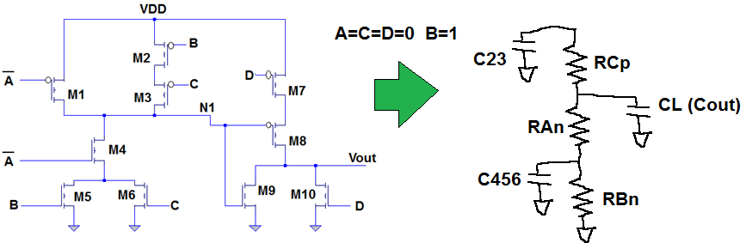

Elmore delay will give you the time constant:



* 1. Find either the equation for tr (rise time) or tf (fall time) - whichever is appropriate – for N1 for this change in inputs. (3pts)

**ANSWER:**



* 1. Find either the equation for tpHL or tpLH - whichever is appropriate – for N1 for this change in inputs. (3pts)

**ANSWER:**



1. Draw two VTCs (graphs). Draw in values on the VTCs such that if the first VTC is the driving circuit and VTC 2 is the driven circuit, the NML=0.5V and the NMH=1V. (6pts)

**ANSWER:**

The noise margin is something that happens between two circuits:

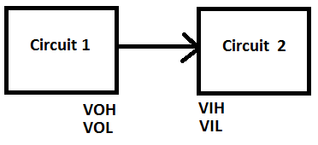

VOH and VOL come from the VTC of the first circuit’s output and VIL and VIH come from the VTC of the second circuit. The definition of NMH is NMH=VOH-VIH and should equal 1V. So VOH is VIH+1V. How about VOH equal to 2.9V and VIH equal to 1.9V (there are an infinite number of answers). I’ll mark those on a graph:

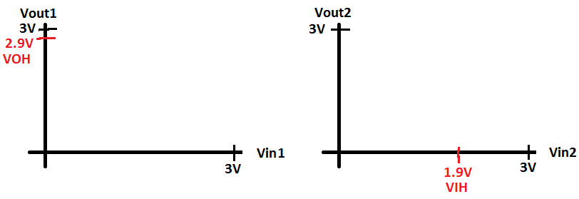

Next looking at NML. The definition of NML is NML=VIL-VOL and should equal 0.5V. So VIL is VOL+0.5V. How about VIL equal to 0.7V and VOL equal to 0.2V (there are an infinite number of answers). I’ll mark those on a graph:

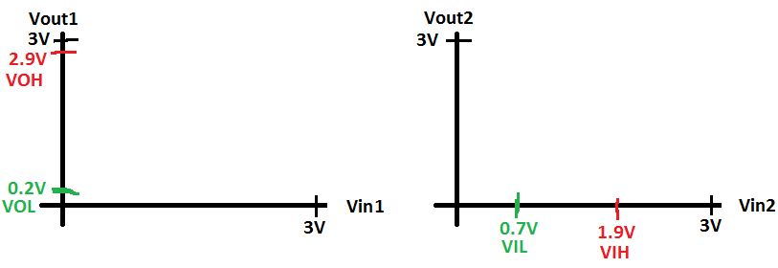

Those marks need to be on the -1 slope points. We’ve just looked at VTCs for inverters so I’ll draw this in as an inverter. Anything like this will be OK:

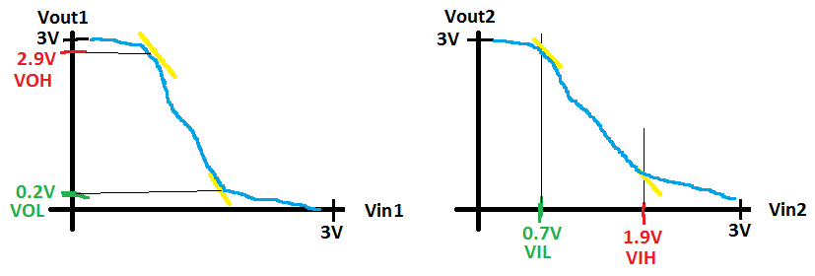

1. (5pts) Explain the equation: 

**ANSWER:**

I’ll divide it into two parts:

 is the energy used for a single transition of the output from zero to VDD. A transition from 0🡪1 is the only time that energy is used.

 is the number of times you have a transition from 0🡪1 on the output in a second. Freq is how many times per second there could be a transition and  is the average percentage of transitions that are 0 🡪 1. Multiplying the percentage times the frequency gives how many transitions there are, on average, per second.

**Graph 1:**

|  |  |  |  |  |  |  |  |  |  |  |  |  |  |  |  |  |  |  |  |  |  |  |  |  |  |
| --- | --- | --- | --- | --- | --- | --- | --- | --- | --- | --- | --- | --- | --- | --- | --- | --- | --- | --- | --- | --- | --- | --- | --- | --- | --- |
| **I for PMOS - mA** | | | | | | | | | | | | | | | | | | | | | |  |  |  |  |
| **-25** |  |  |  |  |  |  |  |  |  |  |  |  |  |  |  |  |  |  |  |  |  |  |  |  |  |
|  |  |  |  |  |  |  |  |  |  |  |  |  |  |  |  |  |  |  |  |  |  |  |  |  |
|  |  |  |  |  |  |  |  |  |  |  |  |  |  |  |  |  |  |  |  |  |  |  |  |  |  |
|  |  |  |  |  |  |  |  |  |  |  |  |  |  |  |  |  |  |  |  |  |  |  |  |  |  |
| **-20** |  |  |  |  |  |  |  |  |  |  |  |  |  |  |  |  |  |  |  |  |  |  |  |  |  |
|  |  |  |  |  |  |  |  |  |  |  |  |  |  |  |  |  |  |  |  |  |  |  |  |  |
|  |  |  |  |  |  |  |  |  |  |  |  |  |  |  |  |  |  |  |  |  |  |  |  |  |  |
|  |  |  |  |  |  |  |  |  |  |  |  |  |  |  |  |  |  |  |  |  |  |  |  |  |  |
| **-15** |  |  |  |  |  |  |  |  |  |  |  |  |  |  |  |  |  |  |  |  |  |  |  |  |  |
|  |  |  |  |  |  |  |  |  |  |  |  |  |  |  |  |  |  |  |  |  |  |  |  |  |
|  |  |  |  |  |  |  |  |  |  |  |  |  |  |  |  |  |  |  |  |  |  |  |  |  |  |
|  |  |  |  |  |  |  |  |  |  |  |  |  |  |  |  |  |  |  |  |  |  |  |  |  |  |
| **-10** |  |  |  |  |  |  |  |  |  |  |  |  |  |  |  |  |  |  |  |  |  |  |  |  |  |
|  |  |  |  |  |  |  |  |  |  |  |  |  |  |  |  |  |  |  |  |  |  |  |  |  |
|  |  |  |  |  |  |  |  |  |  |  |  |  |  |  |  |  |  |  |  |  |  |  |  |  |  |
|  |  |  |  |  |  |  |  |  |  |  |  |  |  |  |  |  |  |  |  |  |  |  |  |  |  |
| **-5** |  |  |  |  |  |  |  |  |  |  |  |  |  |  |  |  |  |  |  |  |  |  |  |  |  |
|  |  |  |  |  |  |  |  |  |  |  |  |  |  |  |  |  |  |  |  |  |  |  |  |  |
|  |  |  |  |  |  |  |  |  |  |  |  |  |  |  |  |  |  |  |  |  |  |  |  |  |  |
|  |  |  |  |  |  |  |  |  |  |  |  |  |  |  |  |  |  |  |  |  |  |  |  |  |  |
|  |  |  |  |  |  |  |  |  |  |  |  |  |  |  |  |  |  |  |  |  |  |  |  |  |  |
| **0** |  |  |  | **-0.5** | |  |  | **-1** | |  |  | **-1.5** | |  |  | **-2** | |  |  | **-2.5** | | **-3 VDS** | | | | |
| **Graph 2:** | | | | | | | | | | | | | | | | | | |  |  |  |  |  |  |  |
| **I for NMOS - mA** | | | | | | | | | | | | | | | | | | | | | | | |  |  |
|  |  |
| **25** |  |  |  |  |  |  |  |  |  |  |  |  |  |  |  |  |  |  |  |  |  |  |  |  |  |
|  |  |  |  |  |  |  |  |  |  |  |  |  |  |  |  |  |  |  |  |  |  |  |  |  |
|  |  |  |  |  |  |  |  |  |  |  |  |  |  |  |  |  |  |  |  |  |  |  |  |  |  |
|  |  |  |  |  |  |  |  |  |  |  |  |  |  |  |  |  |  |  |  |  |  |  |  |  |  |
| **20** |  |  |  |  |  |  |  |  |  |  |  |  |  |  |  |  |  |  |  |  |  |  |  |  |  |
|  |  |  |  |  |  |  |  |  |  |  |  |  |  |  |  |  |  |  |  |  |  |  |  |  |
|  |  |  |  |  |  |  |  |  |  |  |  |  |  |  |  |  |  |  |  |  |  |  |  |  |  |
|  |  |  |  |  |  |  |  |  |  |  |  |  |  |  |  |  |  |  |  |  |  |  |  |  |  |
| **15** |  |  |  |  |  |  |  |  |  |  |  |  |  |  |  |  |  |  |  |  |  |  |  |  |  |
|  |  |  |  |  |  |  |  |  |  |  |  |  |  |  |  |  |  |  |  |  |  |  |  |  |
|  |  |  |  |  |  |  |  |  |  |  |  |  |  |  |  |  |  |  |  |  |  |  |  |  |  |
|  |  |  |  |  |  |  |  |  |  |  |  |  |  |  |  |  |  |  |  |  |  |  |  |  |  |
| **10** |  |  |  |  |  |  |  |  |  |  |  |  |  |  |  |  |  |  |  |  |  |  |  |  |  |
|  |  |  |  |  |  |  |  |  |  |  |  |  |  |  |  |  |  |  |  |  |  |  |  |  |
|  |  |  |  |  |  |  |  |  |  |  |  |  |  |  |  |  |  |  |  |  |  |  |  |  |  |
|  |  |  |  |  |  |  |  |  |  |  |  |  |  |  |  |  |  |  |  |  |  |  |  |  |  |
| **5** |  |  |  |  |  |  |  |  |  |  |  |  |  |  |  |  |  |  |  |  |  |  |  |  |  |
|  |  |  |  |  |  |  |  |  |  |  |  |  |  |  |  |  |  |  |  |  |  |  |  |  |
|  |  |  |  |  |  |  |  |  |  |  |  |  |  |  |  |  |  |  |  |  |  |  |  |  |  |
|  |  |  |  |  |  |  |  |  |  |  |  |  |  |  |  |  |  |  |  |  |  |  |  |  |  |
| **0** |  |  |  | **0.5** | |  |  | **1** | |  |  | **1.5** | |  |  | **2** | |  |  | **2.5** | | **3 VDS** | | | | | |